“**Experiment 1.4”**

**Student Name: SUMIT KUMAR UID: 20BCS8226**

**Branch: CSE Section/Group: DM-720 A**

**Semester: 6th Date of Performance: 20-03-23**

**Subject Name: Data Mining Lab Subject Code: 20CSP-376**

**Aim:**

Demonstration of FP Growth algorithm on supermarket data.

**Objective:**

Association rule mining finds interesting associations and relationships among large sets of data items. This rule shows how frequently an itemset occurs in a transaction. Given a set of transactions, we can find rules that will predict the occurrence of an item based on the occurrences of other items in the transaction.

**Code:**

* Creating Records :

setwd("D:\\ Data Mining") library("arules") data("Mushroom")

Fp_output <- fim4r(Mushroom, method = "fpgrowth", target = "rules", supp = 60, conf = 50)

* Applying Operations :

Fp_output inspect(Fp_output [1:5])

Data_File<- as(Fp_output,"data.frame") write.csv(Data_File, file="DM_Exp_2.csv")

**Output:**

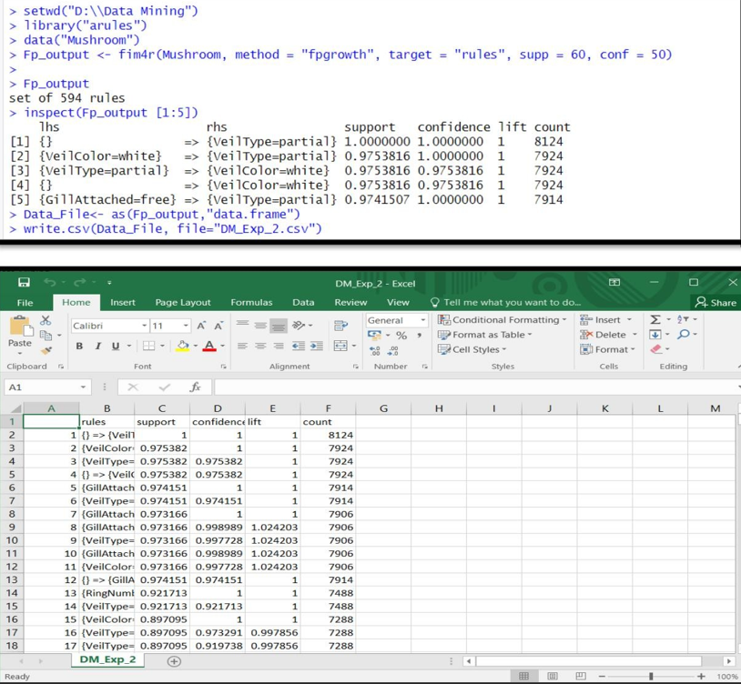

## Observations & Conclusion:

The "fim4r" function is used to mine frequent itemsets and generate association rules using the "fpgrowth" method with a minimum support of 60% and minimum confidence of 50%. The output of the function is stored in the "Fp_output" variable, which is then inspected using the "inspect" function to display the first five association rules.

## Learning outcomes (What I have learnt):

* 1. Association rule mining: Students can learn how to use different methods, such as Apriori or FP-Growth, to mine frequent itemsets and generate association rules.
  2. Minimum support and confidence: The code uses the minimum support and minimum confidence parameters to filter out weak rules and ensure that only meaningful rules